Biosecurity briefing for the allied pig industry
This document is part of the standard operating procedures (SOPs) for porcine epidemic diarrhoea (PED) and is identified as SOP 14.

What is PED?
PED is a highly contagious gastrointestinal disease of pigs caused by a coronavirus. It does not affect humans or pose a risk to food safety.
More than a decade after its introduction in 2013, porcine epidemic diarrhoea virus (PEDv) continues to circulate within the US swine industry.
The non-INDEL strain, generally regarded as more virulent, remains the predominant lineage in the US with piglet mortality rates of 50–100%.
The virus continues to circulate widely in China. Recent surveillance studies (2023-2024) continue to report high positivity rates in diarrhoeic piglets, typically around 36-48% of tested samples, depending on region.
Multiple genotypes are co-circulating, but G2c/GIIc and other variant strains are now dominant in many regions.
PEDv remains endemic in South Korea. Highly pathogenic G2b strains have been dominant since the 2013-2014 epidemic and continue to evolve locally.
In 2026, Korean researchers reported the emergence of a G2c variant closely related to contemporary Chinese strains, which caused severe disease and 100% mortality in experimentally infected piglets.
In Japan, PEDv re-emerged in 2013 after a long period of relative absence, resulting in major losses affecting approximately 1.2 million pigs. The disease is still considered endemic at a low level, with sporadic outbreaks occurring despite vaccination and control measures.
As of July 2026, there were no cases of PEDv diagnosed in the UK and keeping it out remains a priority. The UK pig industry must remain vigilant and maintain good biosecurity.

Symptoms
PEDv can present with a range of clinical signs. Symptoms may include:
- Watery diarrhoea (Figure 1)
- Mild systemic signs such as fever, anorexia, lethargy and sometimes wasting (Figure 2)
- On post‐mortem, the small intestine is ﬁlled with yellow ﬂuid, thin-walled and distended.
These symptoms can be seen with other endemic diseases, such as salmonella and swine dysentery, but if any symptoms are suspicious or unusual, inform the oﬃcial veterinarian (OV) for the plant.
Disease has mostly been seen in piglets but has also been seen in fattening pigs and adults, often associated with moving and/or mixing of groups.
Figure 1. Piglets with watery diarrhoea
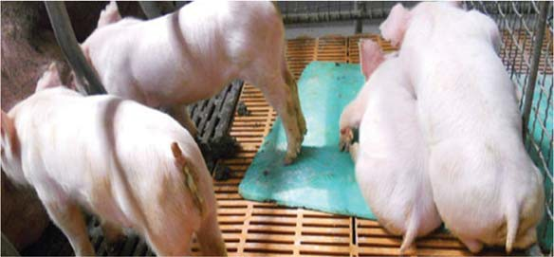
Source: pig333.com
Figure 2. Runt piglets with vomiting, wasting and diarrhoea typical of PEDv in current outbreaks in Asia
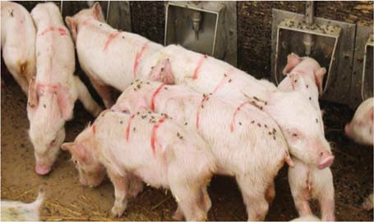
Source: pig333.com

Best practice
Some of the following biosecurity protocols can be implemented when entering a farm to minimise the risk of spreading diseases (refer to PED SOP 4 Farmgate biosecurity – People and PED SOP 5 Farmgate biosecurity – Vehicles).

Farm deliveries
Deliveries and collections present a potential route for disease transmission and should be managed carefully.
When making deliveries or collections, consider the following:
- All vehicles entering the farm must be properly cleaned, disinfected and dry
- It is essential that no faecal contamination is present on the vehicle as this is one of the main transmission routes of enteric diseases such as swine dysentery
- Pay particular attention to areas that come into contact with the farm, such as boots (cab footwells), equipment (feed pipes, driving boards, etc.) and loading ramps
- The farm should supply you with PPE, e.g. disposable boots and overalls, and waterproof trousers and boots if you’re collecting pigs; thoroughly clean and disinfect any PPE used
- Never enter a pig building and avoid heavily contaminated areas if possible
- Disinfect wheels and wheel arches before and after leaving the farm
- Make sure you know the disease status of all farms you are visiting so deliveries of feed/collection of live or dead pigs from diseased farms are scheduled at the end of the week

Overseas visits
Overseas travel can increase the risk of introducing new diseases and disease strains into the UK.
Make sure you take the following precautions:
- Only essential overseas visitors should be allowed onto pig farms, and they must have entered Great Britain at least 72 hours before their visit
- Visitors must use the clothing and footwear provided by the unit
- If you are returning from overseas, avoid direct contact with pigs for 72 hours after any contact with pigs overseas
Make sure your staﬀ and colleagues are aware of the risks posed by the new strains of PEDv and that they comply with all biosecurity measures requested of them.
Encourage all pig keepers to contact their veterinarian immediately if they notice unusual or severe diarrhoea, especially in young piglets.
Be prepared to review the source and safety of any nutritional products used on the farm and assess whether any of them could introduce or increase disease risk.

Explore further resources on PEDv
This source provides additional information and up‑to‑date guidance on PEDv:
- All SOPs are available on our website – ahdb.org.uk/PEDv
